Download Python:

Visit the official Python website at https://www.python.org/downloads/windows/ and download the latest Python installer for Windows. Choose the version that matches your system (e.g., 32-bit or 64-bit).

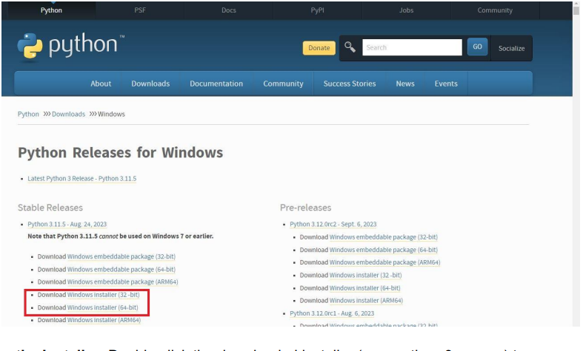

Run the Installer:

Double-click the downloaded installer (e.g., python-3.x.x.exe) to run it. Make sure to check the box that says "Add Python X.X to PATH" during installation. This option is essential for using Python from the command line.

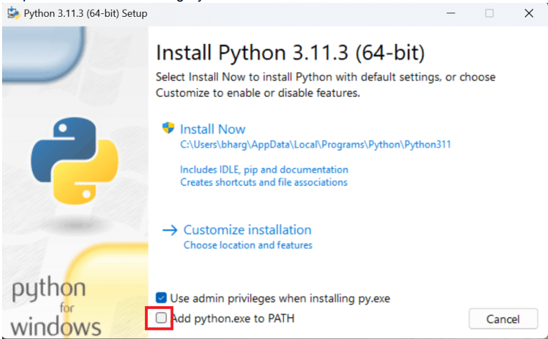

Install Python:

Click "Install Now" to start the installation process. Python will be installed on your system

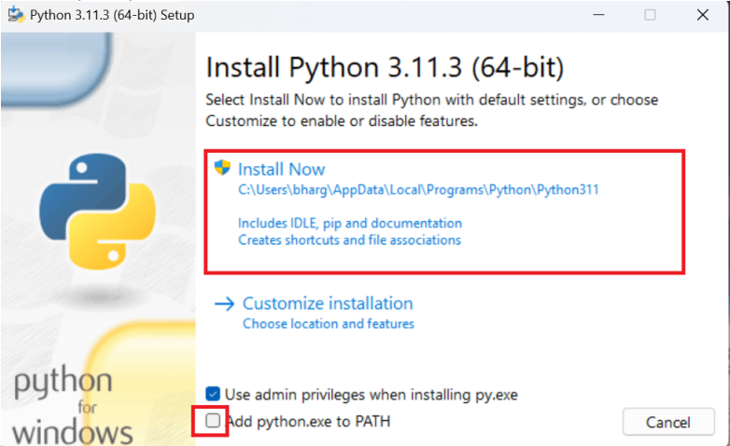

**Verify:**

To verify that Python was installed correctly, open the Command Prompt (search for "cmd" in the Windows Start menu), and type python --version. You should see the installed Python version displayed.

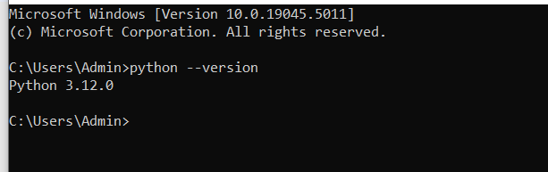

**Program:**

